

**Marketing the “Happy Way” to create an overall experience**

**Happy Employees = Happy Residents = Happy Property**

**Day 1 ~ 3:10-4:30**

Facilitators: Becca Sanford, Dianne Patton, Kim Nations, Devin Cade, Jeanette Roscoe

**Mission Statement**: Our goal with this roundtable is to demonstrate the importance of social media as well as marketing in general. It is the long game plan! Not just the short term! Not just the posting but the engagement. Engaging residents and creating a brand. We plan to do this with real life examples, how you can combine promoting on social media as well as marketing, and real-life events at the communities that result in higher reviews and more happy teams and residents!

**Room Décor**: Displays of our properties Marketing Items, pom poms, TBD.

**Music:** [Tate High School Band](https://www.youtube.com/watch?v=KF9wi8rZwhE&t=253s)

<https://www.youtube.com/watch?v=KF9wi8rZwhE&t=253>

**3:10 – 3:15 Enter the room**

* **Look at marketing displays we have around the room from each prop**
* **Put down their belongings**
* **Ask them to form two lines to prepare for the icebreaker**

**3:15-3:25: Icebreaker: *Lights off –* Glow in dark Charades**

*(Slide 2)*

**Glow In the Dark Charades (themed school related events)**

Fill a large cardboard box with an assortment of [**glow-in-the-dark accessories**](https://linkprotect.cudasvc.com/url?a=https%3a%2f%2famzn.to%2f3wk6HAg&c=E,1,m9u3CteMFXRKtdXaOA-gqXtQm_pKM8aDwdDd7hLHa4qRJGybb6nb8ctg9PYI8az4MgScv2LYllLR8HJpcBqtP0QMnxaHIqUHt5AlfbchgfSoMpp-&typo=1). Include glowing batons, neon headbands, glow sticks, glow bracelets, glow necklaces, and more. Now let one participant at a time reach into the box and use these accessories to act out an activity such as juggling or bowling.

The other participants can then try and guess what activity is being performed. The only real cues will be how the neon-colored accessories are being handled and used. Think of this as a new and improved form of charades. Introduce yourself as you take a turn 19 per class as fyi for options on executing this.

**3:25 – 3:30 Southwest Video**

*(Slide 3)*

<https://youtu.be/cN9ECvpIXkA>

To Class: What did you get from this video?

Reacting vs. innovating.

* + **How do we react to challenges in our market, policies, marketing, etc.**
    - **New construction.**
    - **Comps giving larger concessions.**
    - **COVID – had to react and find new methods to get traffic.**
  + **How do we innovate ourselves to be above the rest?**
    - **New/on-going resident events.**
    - **New marketing swag for residents/prospects/companies.**
    - **On-going team training and idea sharing.**

**3:30-3:35 Happy Employees – Quick Overview:**

*(Slides 4-5)*

To Class: What do you do to motivate your team and create a Happy Team environment?

* + **Setting attainable goals**
  + **Positive reinforcement - recognizing employee/team accomplishments.**
  + **Friendly contests among staff with prizes.**
  + **Team building meals.**
  + **Bonuses**
  + **No negativity in the office**
  + **Being kind to one another**
  + **Communicating effectively**
  + **Offering some flexibility in schedule**
  + **Listening to employee concerns**
  + **Set the example**
* We think it’s important to emphasize that a Happy Employee will exude a positive reflection for the community in the marketing efforts!

**3:35-3:50 Let’s start with the basics: Marketing Materials: (NEED BOARD)**

*(Slides 6-7) (HANDOUT – Logo Game, just to demonstrate success branding)*

* We will all bring our goodies from our properties and display around the room
* To Class: What types of materials have you ordered for your properties and where do you order from?
  + - **Make list on board**
    - **Show full list from Brad at MDX for what properties have ordered and costs**
* To Class: What do you do with these items? How do you distribute?
* **Put a break room basket full of your properties’ goodies at some large corporations that won’t let us market to them**
* **Leave property branded items out in leasing office for prospects / residents to take**
* **Make goody bags of your prop branded stuff for prospects to have after touring**
* **Hand out property branded stuff at resident events**
* **Take property branded goodies to local businesses**
* **Make list on board of other ideas**
* To Class: How do you do focused marketing to particular businesses in the area? Where and What have you put together?
* **Get a branded treat bowl that we re-stock for vet offices and/or pet day cares.**

**(pet treats, doggie bags).**

* **Break Room Baskets (branded cups, snacks, pens, hand sanitizer, nail files, brochures**
* **Waiting Room Marketing; ie Dr office, hair salon, etc. (Branded coloring books and crayons)**
* **Real Estate Offices; market your short-term leases, realtor referral, or furnished corporate units**
* **School Sponsors; sponsor zoned schools’ sports teams with banners stating proudly zoned XYZ school.**
* **Support Local; put together a “Perks” card featuring local businesses and have them offer discount to your residents**
* **Pool Day; Branded towel, branded sunscreen, and branded sunglasses**
* **Winter Day: Branded Mug, hot chocolate and all the goodies to go with**
* Show us some differences between marketing items for residents vs. prospects/businesses.
* **In most circumstances, we’re not going to give prospects/businesses large ticket items, but save those for move-in gifts/resident events.**

**3:50-4:15:** **Social Media**

*(Slide 8-16)*

* How do you use social media at your property?
  + **To announce events**
  + **To create your brand**
  + **“Meet the staff”**
  + **To connect with our residents, with prospects in mind**
  + **To motivate / entertain your followers**
  + **Make sure photos are good quality, check your backgrounds, etc… Always think………does your post represent your property well?**
* Social media should be used to market to our residents with prospects in mind.
  + What we mean by this is that ***when prospects visit our social media pages, they should view it as a community they want to live at based on the posts/engagement*** we have with our current residents.
  + Most of our followers are already familiar with the community, so we ***shouldn’t be posting about open apartments*** on social media (except for Marketplace and similar uses that is separate from our business pages).
* **Not to be used for negative things onsite. Ie lease violations, warnings, etc.**
* How do you build your social media following?
  + **Invite prospects on the phone to check it out**
  + **Move in packets have QR code with our social media**
  + **At resident events: have QR codes to our social media**
  + **Email / text residents, with teasers that additional incentives are offered to our social media followers**
  + **Post flyers by resident mailbox**
* What platforms do you use for your posts?
  + **Canva, Hootsuite**
  + **Later.com**
  + **TikTok videos**
  + **Meta in Facebook**
  + **CapCut video editor.**
* How are each of these platforms uniquely used in our marketing efforts?
* **Canva: make flyers, social media templates, presentations**
* **Later.com & Hootsuite: preschedule posts**
* **TikTok / Capcut video editing, to create social media post, video tours,**
* Break away into 4 groups (4.5 people per group) based on skill level and experience.

Estimating a total of 38 people, about 19 per class currently.

* + *EACH PERSON NEEDS TO BRING A DEVICE THEY CAN USE DURING CLASS TO LOOK ON THEIR PROPERTY SOCIAL MEDIA.*
  + *EACH PERSON NEEDS TO HAVE THEIR PROPERTY FB, INSTAGRAM, AND CAPCUT APS DOWNLOADED ON THEIR DEVICE AND KNOW THEIR LOG IN Prior to coming to class*
* We will look up our competitor’s social media pages
* **What do you see that you like, or what do you see that doesn’t look good?**
* **Tell the room the pros / cons, what stood out the most?**
* **Look for examples to show the class**
* **What improvements were needed and how would we do it differently?**
* Will show Michelson Property Social Media campaigns on Canva some Capcut videos that were successful and share with class why / how.
* **Ask the room to share some photos of pictures they have taken since Tuesday mixer and Wednesday.**
* **We will put together a quick Capcut video of these pictures / videos from 2023 conference**.

**4:15-4:30** **REVIEWS:**

*(Slides 17- 23) (HANDOUT - Review Responses)*

* To tie this all in together… how can we use our Marketing efforts to get great reviews?
  + **QR codes residents can scan during events.**
    - [www.qr-code-generator.com](http://www.qr-code-generator.com)
* We will also use the presenting computer to pull this up and create QR code
  + **Create QR code handouts to give to residents who have positive interactions in the office.**
  + **Have a tablet available with links to review sites to use during your social events.**

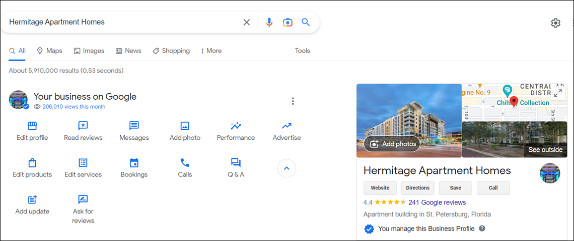

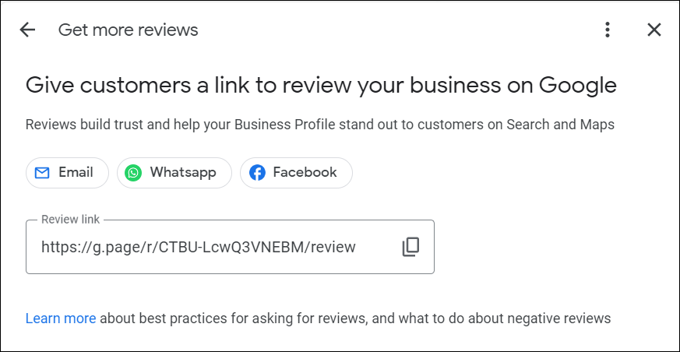

Email templates to respond to positive resident feedback/surveys.

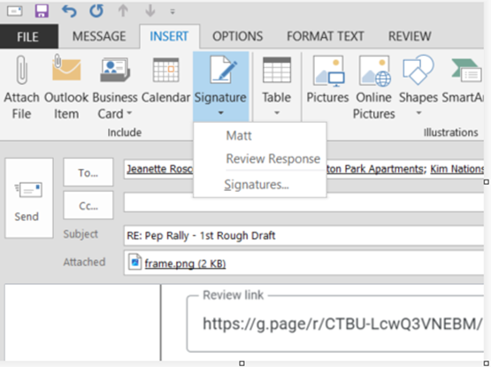

* Article about reputation management:
* <https://blog.reachbyrentcafe.com/2022/07/08/apartment-reviews/#:~:text=According%20to%20the%202022%20NMHC,important%20way%20to%20increase%20conversions>.

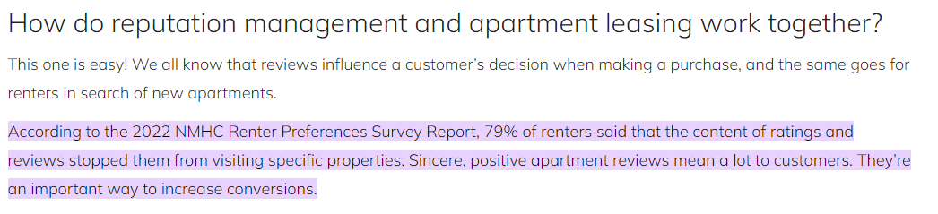

-Include appropriate steps to responding to reviews, especially negative ones. (Handouts: examples of responses for positive and negative reviews).

* + **Thank the reviewer, don’t get personal, don’t attack the person, recognize the concern, advise them if anything’s been done, and encourage them to reach out to the office to discuss.**

In closing: Get everyone on their feet and pumped up about what we learned and working for MRC!

Have class chant with us:

Pep Rally Closing Chant

Facilitators: Pump, pump, pump it up!

**Class: Pump, pump, pump it up!**

Facilitators: Pump, pump, pump it up!

**Class: Pump, pump, pump it up!**

Facilitators: Keep, Keep, Keep it up!

**Class: Keep, Keep, Keep it up!**

Facilitators: Keep, Keep, Keep it up!

**Class: Keep, Keep, Keep it up!**

Facilitators and Class MRC, MRC,

**Class: MRC, MRC, MRC**

Play as exit the room:

We Ready (ATL Falcons)

<https://youtu.be/5Ovt5mJRCEw>